Bank Account Management

Technical Story Card Revision History

Version No. | Date | Prepared by / Modified by | Significant Changes
1. | 10.02.2022 | Seema Singh | Introduction Added
2. | 13.02.2022 | Sweety Catherine | ER Diagram Added
3. | 15.02.2022 | Seema Singh | Use Case Model Added
4. | 16.02.2022 | Seema Singh | Process Model Added
6. | 23.02.2022 | Seema Singh | UI design pages screenshot added
7. | 24.02.2022 | Seema Singh | Scope of change added
8. | 26.02.2022 | Sweety Catherine | Sequence Diagram added
9. | 28.02.2022 | Sweety Catherine | Use-Case Model Description added
10. | 03.03.2022 | Sweety Catherine | Architecture Diagram added
11. | 04.03.2022 | Sweety Catherine | Class Diagram added
12. | 05.03.2022 | Sweety Catherine | Scope of Change modified
13. | 06.03.2022 | Sweety Catherine | Transaction Description added
14. | 07.03.2022 | Sweety Catherine | Welcome page description added
15. | 08.03.2022 | Sweety Catherine | Account Detail description added
16. | 18.03.2022 | Sweety Catherine | Registration Page added
17. | 19.03.2022 | Sweety Catherine | Sequence Diagram modified
18. | 23.03.2022 | Sweety Catherine | Reference section added

Glossary
Abbreviation | Description
BSC | Business Story Card
TSC | Technical Story Card
DOJ | Date of joining

Table of Contents
1 Introduction 3
2 Scope of Change 3
3 List of impacted modules 3
4 Design and Detailed technical updates 4
4.1 Process model 4
4.1.1 Use case Model 4
4.1.2 Sequence diagram 4
4.1.3 Architecture diagram……………………………………………………….......................4
4.1.4 Class diagram………………………………………………………………....4
4.2 Proposed user Interface design 4
4.3 Database design changes 4
5 References 5

Introduction
The adoption of electronic banking by commercial enterprises has been in existence since the mid 90s, much greater in number due to lower operating costs associated with it. Electronic banking has initially been in the form of automatic teller machines and telephone transactions. More recently, it has been transfer made by the Internet, a new delivery channel for banking services that benefit customer.

The bank management system is an application for maintaining an already existing customer's account in a bank. The system provides the access to the customer to deposit/withdraw the cash from his account. This application also provides other options like viewing their last transaction and total transactions that the customer has done so far. The customer can also view the outstanding balance. Using any of these options customer will interact with the application and do the corresponding operations.

Scope of Change
- We can include application for Loan in this project in the future.
- We can also include some other options like generating Bank statement in the form of pdf once they done the transaction.
- We can include the option for paying the bills via application.
- We can also implement the functionality for scan and pay method.

List of impacted modules
All the functional modules will be created from scratch.

Design and Detailed technical updates

Process model

Use case Model

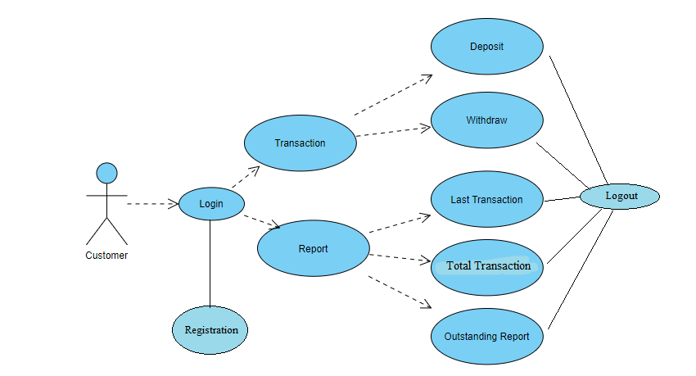

Brief Description | Customer operations in Bank Account
Basic Flow | Customer can login to the account  - Deposit Money  - Withdraw Money  - View the transaction report  Using any of these options customer will interact with the application. It will display the reports on last transaction, total transaction and outstanding amount.
Alternate Flow | - The system will validate the information provided. If any invalid data is found, the input form will be redirected with error message.
Validation | - Balance amount is required minimum of Rs.1000.
Pre-Conditions | Customer should have network access and Browser with latest updates.
Post-Conditions | Success message should be shown.

Sequence diagram

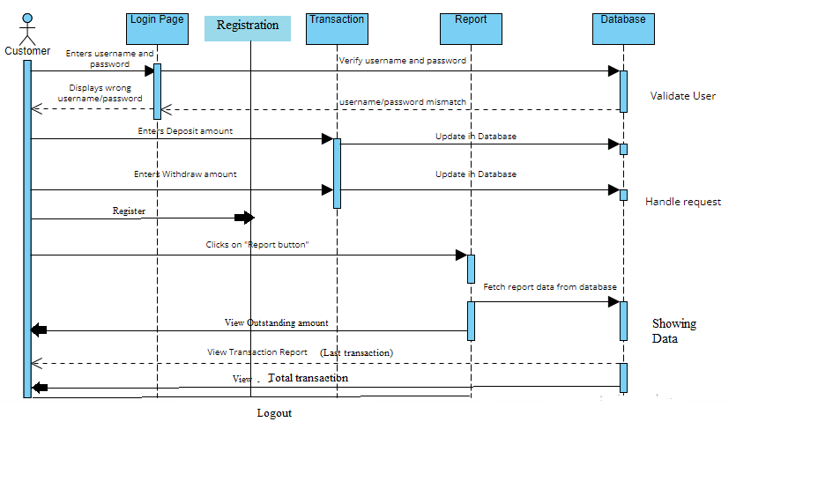

Architecture Diagram

Layer
Logical View
Technology/ Framework

UI Components
Presentation Layer
HTML 5/ CSS/ Angular 8
Service
Directives

Template

Component

Web-Server Classes
Java 8/ Spring Boot 2.5.10/Spring Data JPA
Application/ Business Layer
Configuration
Controllers

Service
REST Controllers

Entity/ Model Classes

Data Access Layer
Repository classes

Oracle 11g Database

Presentation Layer:
This layer consists of all UI components.
- Login Component: Customers can use the login component to login to their respective accounts.
- Registration Component: The new coming customers should register in this registration page by giving all the required details.
- Deposit Component: Customer can use the Deposit component to deposit an amount in his/her account
- Withdraw component: Customer can use the Withdraw component to withdraw an amount from his/her account
- Report component: By using Report component customer can get the report by either their last transaction or total transaction or outstanding amount.

Application Layer:
This layer comprises of all server and business classes.
- Configuration settings (XML or Class based) will define the application and server configuration.
- Spring Controllers defines the server classes, which are required to process the incoming http requests.
- Service classes are required to perform the required business services.
- REST Controllers to process the HTTP AJAX requests.
- Model classes are used the define the functions of the entities present in the system.

Data Layer:
Data layer is implemented through Spring JPA. It will contain the repository classes, which provides interface to the table.

Class Diagram

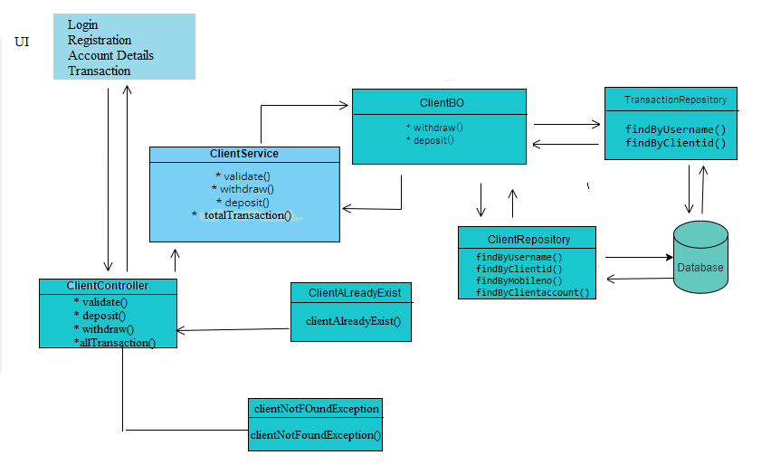

Proposed user Interface design
Login Page
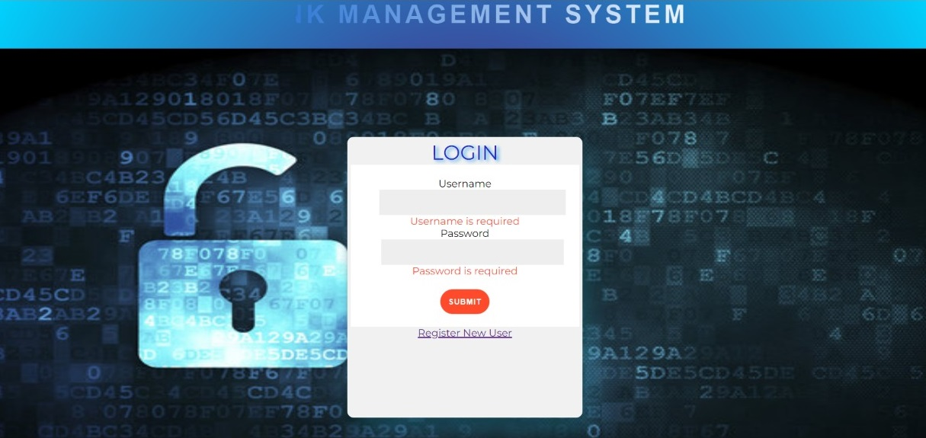

Brief Description | Login
Basic Flow | This page describes how a user log-in in to the system  - The customer has to login himself into the system.  - After the successful login, user will be taken to the appropriate landing page.  - The following information is required to login.  - username  - password
Alternate Flow | - The system will validate the credentials provided. If credentials are invalid, login form will be redirected again with error message.
Validation | - Valid username  - Valid password
Pre-Conditions | User should have network access and Browser with latest updates.
Post-Conditions | After successful login, Home page has to be displayed. Otherwise user has to register a new account.

Registration Page

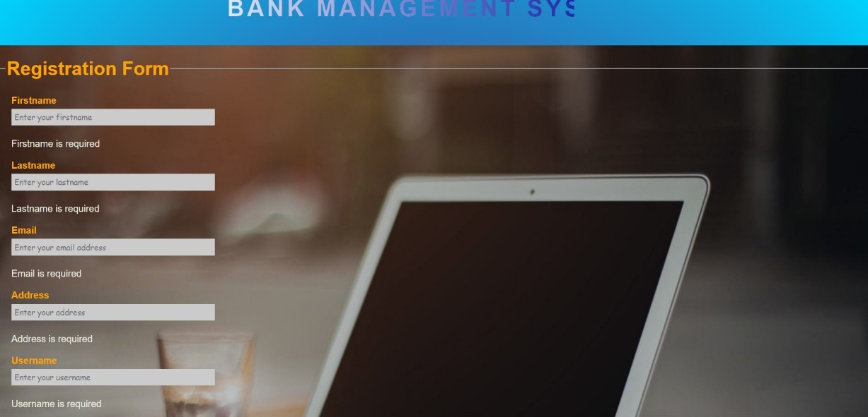
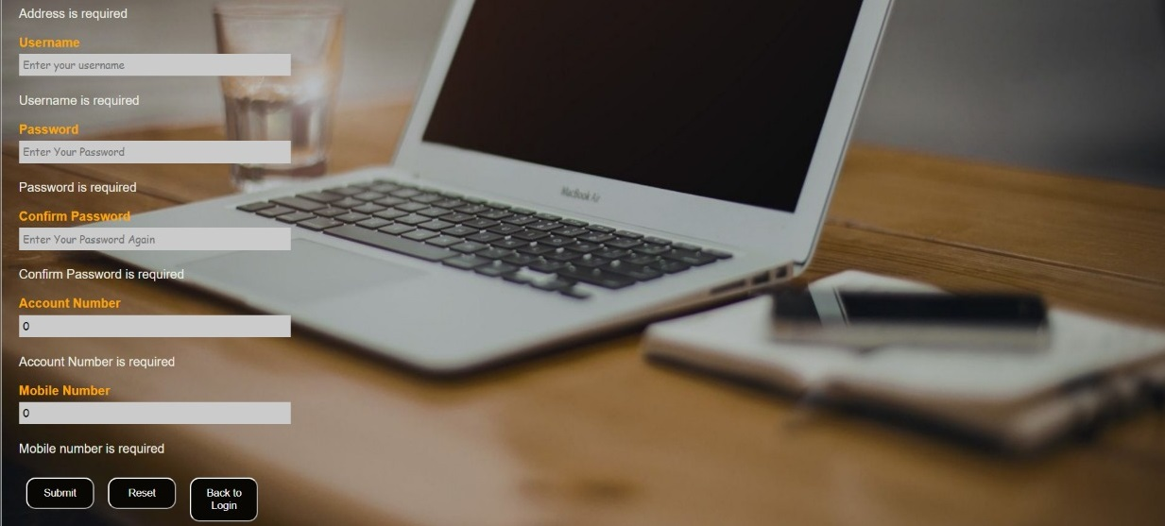

Brief Description | Registration
Basic Flow | - This page is for registering the new customer  - The customer has to give all his details like first name, last name, contact number, email id, residential address, user id and password.
Alternate Flow | The system will collect all the data given and store them in database.
Validation | Valid contact number, email id and password must be given
Pre-Conditions | User should have network access and Browser with latest updates.
Post-Conditions | Login page has to be displayed.

Home Page
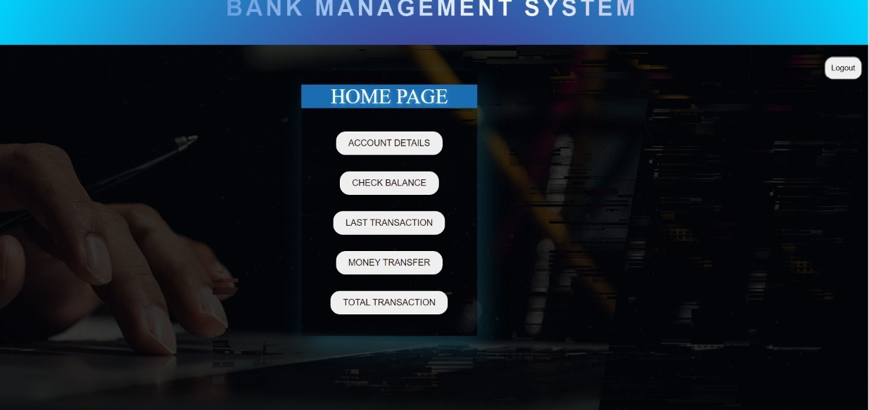

Brief Description | Home Page
Basic Flow | This page describes 3 options  1.The customer can view the account details.  2. The customer can do the money transaction.  3. The customer can view the details of his/her transaction by clicking Total Transaction button.  4. The customer can check the balance amount  5.The customer can view the last transaction.
Alternate Flow | The system will validate the credentials provided.
Validation | The amount entered should be in integer datatype.
Pre-Conditions | User should have network access and Browser with latest updates.
Post-Conditions | Corresponding page has to be displayed.

Account details



Brief Description | Account-Detail
Basic Flow | This page shows the customer account details. It contains:  1.Name of the Customer  2. Account number of the customer  3. Email  4. Date of joining  5. Mobile Number  6. Address
Alternate Flow | The system will show the credentials provided.
Validation | The values entered should be valid data.
Pre-Conditions | User should have network access and Browser with latest updates.
Post-Conditions | By clicking “Home” button, Home page has to be displayed.

Total Transaction Page

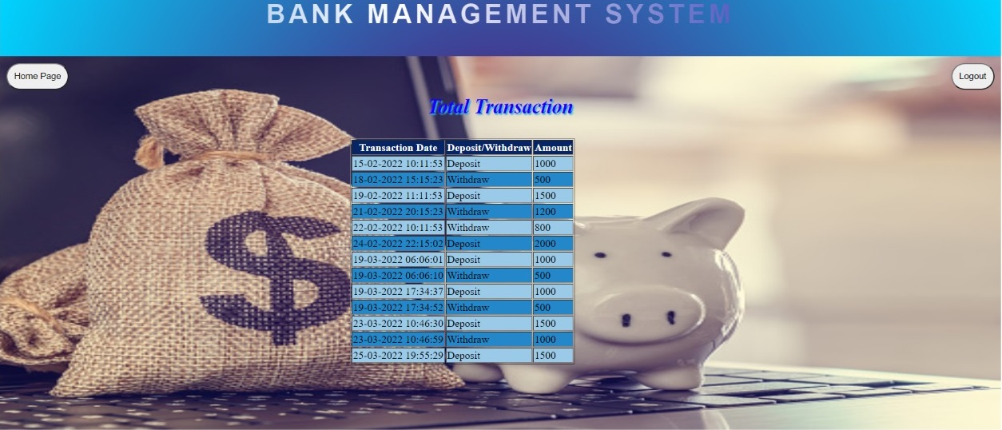

Brief Description | Total Transaction
Basic Flow | This page shows the following details in his/her account.  1.Transaction Date  2. Transaction type - Deposit/Withdraw  3. Deposit/Withdraw amount
Alternate Flow | The system will validate the credentials provided.
Validation | The amount entered should be in integer datatype.
Pre-Conditions | User should have network access and Browser with latest updates.
Post-Conditions | By clicking “Home” page button, it should navigate to the home page.

Money Transfer Page
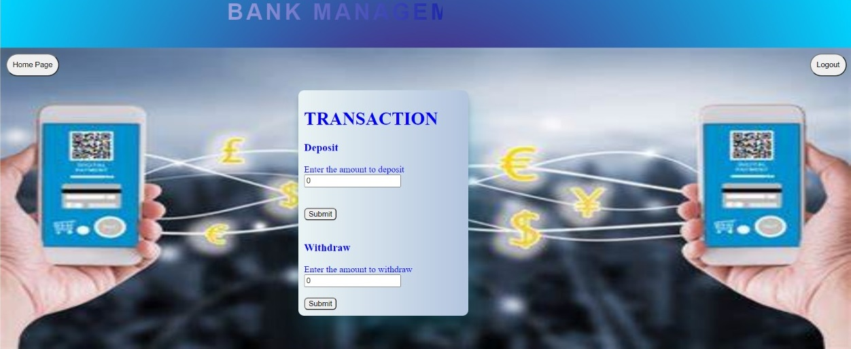

Brief Description | Money Transfer Page
Basic Flow | This page describes 2 options  1.The customer can withdraw amount from their account  2. The customer can deposit money in their account
Alternate Flow | The system will validate the credentials provided.
Validation | The amount entered should be in integer datatype.
Pre-Conditions | User should have network access and Browser with latest updates.
Post-Conditions | The amount that has been entered should be updated in the database.

Database design changes

ER Diagram

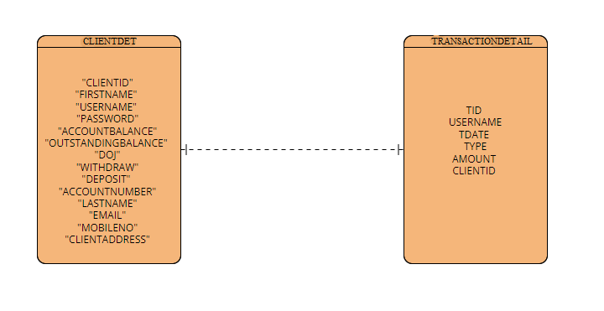

References
We as a team have referred to the content which are given in LMS and completed our project of “Bank Account Management System”. In this training, we learnt so many technologies such as core Java, HTML, CSS, JavaScript, hibernate, spring boot, and Angular. We implemented all the functionalities like login, logout, registration, money transfer operations and report generation based on these technologies.

